U-Tron LED Drivers
U-Tron provides 2 types of driver boards for different LED Lights applications. One is the Boost type and its best suited for Solar Powered units (battery and solar panel). The other one is a Buck type and its better suited for high voltage AC Applications. Both have the same foot print and mounting brackets. Boost type can be also used for regular power supplies found in the market.
Many power supplies found in the market can’t with stand the life cycle expected by the LED lamps. The high quality power supplies that can be guaranteed for 50,000 hours may be very expensive. U-Tron driver boards take your worries away from you. We have designed the Driver boards with proven technology to give 50,000 hours MTBF. This is to match the LEDs that can be found in the market today. When a power supply fails you don’t have to replace the driver boards or the LEDs. All you need to do is to replace the
power supply.
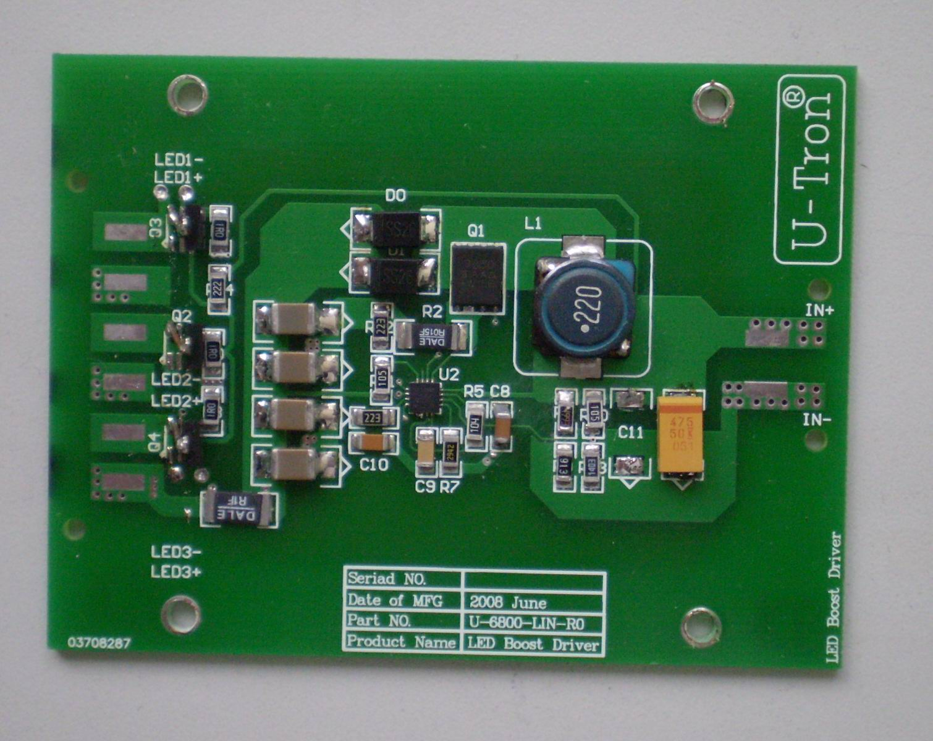
Figure 1
U-Tron Boost Drive PCB Board
Pin 1 and 2
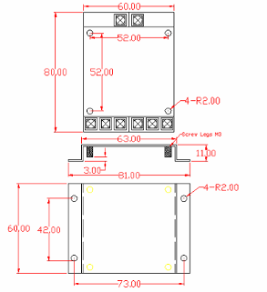

Figure 2
PCB Board Dimensions
Applies to Buck and Boost configurations:

Pin assignments:
Pin 1 – Input DC +
Pin 2 – Input DC – Ground
Pin 3, 5 and 7 – Output DC + to LED Arrays
Pin 4, 6 and 8 – Output DC – Ground to LED Arrays

Boost Type Drivers: Part # U-6800-LIN

For driving the Standard LED U-Tron Lamp sets, we use the Linear Technology voltage regulator chips together with the 3003 splitter or array of similar transistors to divide the current in 3 equal amounts, The LT3755 is a DC/DC controller designed to operate as a constant-current source for driving high current LEDs. They drive a low side external N-channel power MOSFET from an internal regulated 7V supply. The ﬁxed frequency, current-mode architecture results in stable operation over a wide range of supply and output voltages. A ground referenced voltage FB pin serves as the input for several LED protection features, and also makes it possible for the converter to operate as a constant-voltage source. A frequency adjust pin allows the user to program the frequency from 100kHz to 1MHz to optimize efficiency, performance or external component size.

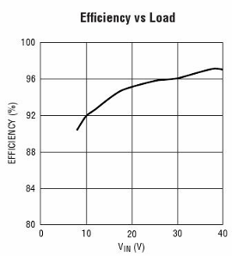
Figure 3

Boost Type Drivers Features
- 3000:1 True Color PWM Dimming
- Wide Input Voltage Range: 9V to 36V
- Output Voltage Up to 70V
- Constant-Current and Constant-Voltage Regulation
- 100mV High Side Current Sense
- Adjustable Frequency: 100kHz to 1MHz
- Programmable Under voltage Lockout with Hysteresis
- Open LED Status Pin (LT3755)
- Frequency Synchronization (LT3755-1)
- PWM Disconnect Switch Driver
- CTRL Pin Provides Analog Dimming
- Low Shutdown Current: <1μA
- Programmable Soft-Start

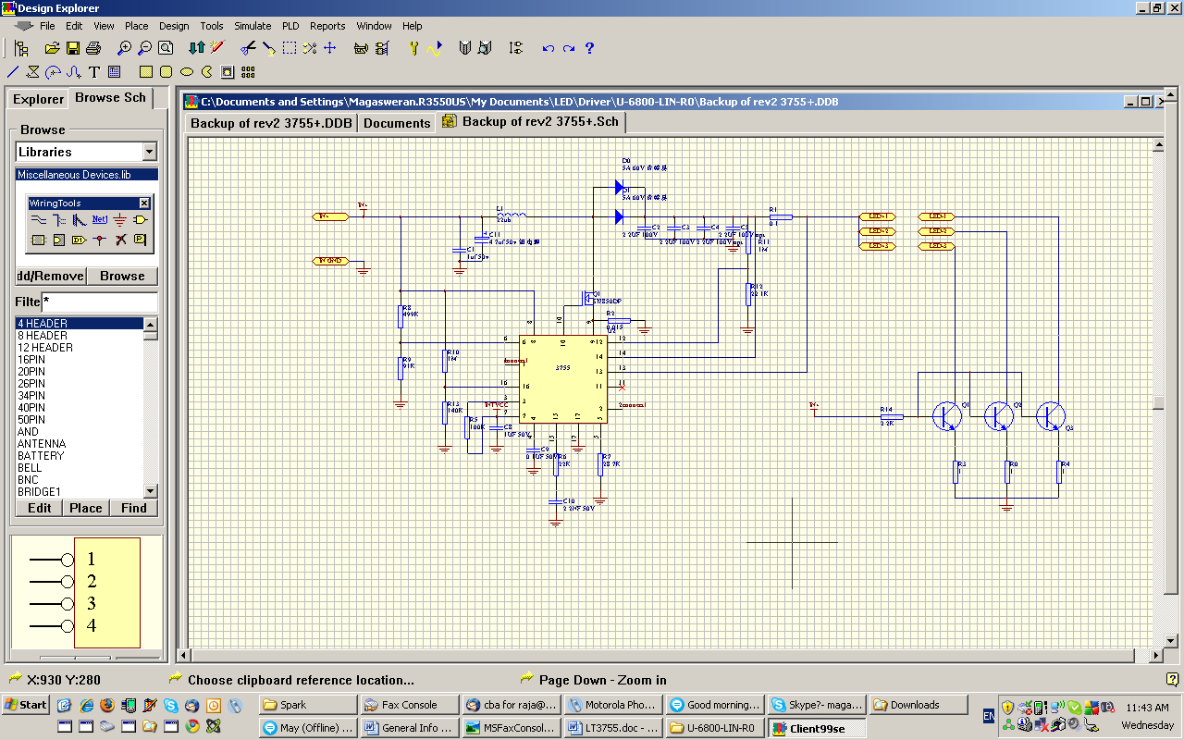
Please specify constant current value when ordering:

Figure 4
Circuit diagram
Ordering part number: 6800-LIN-R2

About the Voltage:

The input voltage can be anywhere between 9V DC to 36V DC
Output voltage can be anywhere between 12V DC to 70V DC.
However, you must operate this driver board in a boost environment.
Meaning, the input voltage must be lower than the output voltage. When connecting LED, make sure you have enough number of LEDs connected in a serial mode to exceed the input voltage. You can use the 3.5V as a guideline for the commercially available LEDs today.

For example: if your power source is a 12 V Batteries then the minimum number of LED you can connect in a serial mode must be more than 4 but less than 20.

If your power source is a 24 Power Supply then the minimum LEDs can’t be less than 8 but again must be less than 20.

About the constant current:

Our boards can be configured to a number of assortments of Constant Current configuration but this has to be done at the time of ordering.

In any event you cannot exceed the Maximum current of1 Amp. U-Tron driver boards are configured to produce 3 equal amounts of 333mA of 3 circuits for connecting 3 sets of parallel LED panels. Please note newer versions may have constant current selector of popular values.

Future Products:
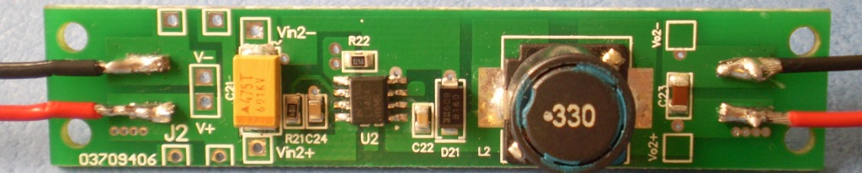
Our new 6800-LIN-SLIM is a slim design that’s gives customers a unique way of configuring the input and output requirements. You can choose 150, 250, 350, 500, 750, 1000 mA just by changing the jumper on the board.

Please note:
- Reverse polarity protection is not available in the older versions. Revision 1, 2 and 3. R4 and the rest will be equipped with the reverse polarity protection.
- Protective cover available upon request.

